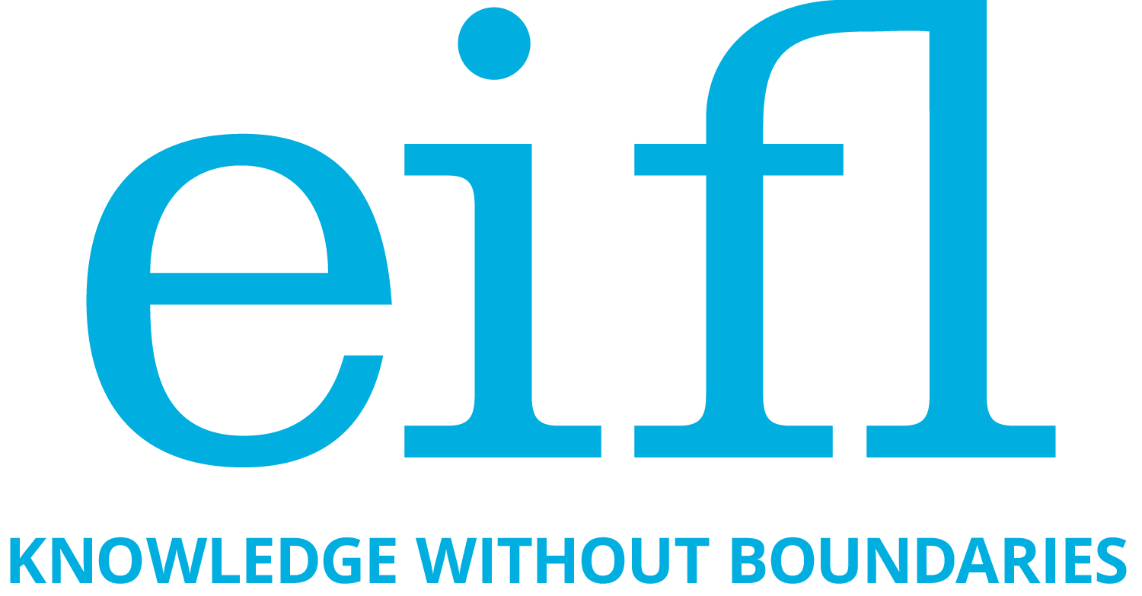

Public Library Innovation Programme

Innovation Award 16
Supported by the LEGO Foundation
Public libraries enabling learning through play

Application form

Type of Library (please mark one):

o Public library – primary source of funding is local/regional/national government.
o Community library – an important source of support is community contribution.

Name/Title of the programme/activity:

Select the category your programme fits most:

o Play in early development (age 0-3)
o Connecting play and education (age 3-12)
o Play & life-long learning (age 12-18)

Library contact information:

Name of the library
Address
Telephone number/s
Country
URL of the library website (If applicable)
Application primary contact person
E-mail address of the primary contact person
Head of the library (name and contacts)

1. Your library: Provide a short description of your library to give the context of this application. Please include a short overview on your library’s other services, programmes and activities, and about the community that the library serves. [Note: We are not seeking a history of the library. We want to know about the library’s current activities and how they are addressing community needs.]
(No more than 200 words)

2. Background of the programme/activity. Please describe your target group in detail. Consider including relevant context information like community statistics, information about living environment, family life and income, available educational and social service infrastructure. Why and when did you start the programme/activity you are presenting for the award? (No more than 200 words)

3. Describe the programme/activity: Please describe in detail the objectives, content and methodology of your programme/activity that enables learning through play. Which characteristics of playful experience does your programme/activity bring (please consult FAQ “What is learning through play?” Do not forget to mention, where the programme/activity takes place and what tools/technologies, if any, it includes.
(No more than 300 words)

4. Why do you believe your programme/activity should win this Award? Explain what is innovative and unique about the programme/activity. Could it be scaled up or replicated to reach more children or inspire other libraries?
(No more than 100 words)

5. Describe the results: Start with a general statement about the overall results of the programme/activity, showing how it enabled children to learn through play. Then include key data, i.e. the number of children reached since the start of the programme, other quantitative and qualitative evidence showing the effectiveness of your programme/activity. To what extent have playful activities resulted in learning, for example, improved the children’s physical, social, emotional, cognitive and creative skills? How have you measured the success of your programme? Please include short testimonials/quotes from the children (and also parents/other family members/carers/teachers and partners, if applicable). Conclude with a highlight – that is, a special story that shows the impact of your programme/activity on the life of a child or children in your community.

Note: Take care to protect people’s privacy: if you are using personal information, like name, surname, age, or information that can identify an address/location of a person, or images, make sure you have permission from the relevant person/people to use this information; especially ask permission from a parent/guardian to use information about children.

(No more than 500 words)

6. Supporting material
- 3 photos showing the programme in action in the library or any other place your activities take place. All photos must be uploaded through the electronic submission system. Take care to protect people’s privacy, as noted under Point 5, above.
- Link/s to Blog/Facebook page/Photo gallery/Articles about the programme/activity.
- This application and all attachments must be uploaded through the EIFL electronic submission system.

APPLICATION SIGNATURE

By signing below, I declare that all statements in the application are accurate and complete.

By submitting this application you consent to EIFL collecting, storing and processing personal information, such as names, surnames and e-mails for the purpose of EIFL-PLIP work. We will not sell, distribute or lease your personal data to third parties unless disclosure is required by law. Click here to read more about EIFL’s Privacy Policy.

Signature of authorized representative | Date
Please print your name

Title

A note: To save time and trouble, you can sign the last page of your application and upload it as an attachment (in pdf format) in the electronic submission system

